电子信息学院
实验报告书

课程名：《WEB系统开发》
题 目： 实验八 MyBatis关联映射
实验类别 【验证、设计、综合】
班 级： 软件2311
学 号： 251103530135
姓 名： 符淏

评语：

成绩： 指导教师： 郭煦

批阅时间： 2025年11月13日

- 实验内容或题目
使用mybatis实现多表查询
- 实验目的与要求
熟悉MyBatis的配置文件
掌握MyBatis映射文件中<resultMap></resultMap>子元素的用法
掌握基于DAO的开发方法
进一步学习使用JUNIT单元测试工具
- 实验步骤与源程序
实验步骤：
- 连接数据库，创建tb_student、tb_course、tb_stu_course三张表，并插入一些测试数据。
- 创建maven项目，在pom.xml中引入mybatis、junit等依赖，创建db.properties、log4j.properties并配置。
- 在bean包下创建数据库中对应的实体类
- 在dao包下创建接口，对应数据库的操作
- 创建mybatis-config.xml并配置mybatis,再创建StudentMapper.xml、CourseMapper.xml、StudentCourse.mapper对应mapper层的接口。
- 在util包下创建MybatisUtil工具类，编写拿到单例SqlSession对象的代码
- 编写测试类
基本要求部分源码：
第6步：持久化类代码
Student:
package cn.edu.sdju.soft.bean;

public class Student {
private Integer id;
private String stuName;
private String major;
private String dormitory;

public Student() {
}

public Student(Integer id, String stuName, String major, String dormitory) {
this.id = id;
this.stuName = stuName;
this.major = major;
this.dormitory = dormitory;
}

public Integer getId() {
return id;
}

public void setId(Integer id) {
this.id = id;
}

public String getStuName() {
return stuName;
}

public void setStuName(String stuName) {
this.stuName = stuName;
}

public String getMajor() {
return major;
}

public void setMajor(String major) {
this.major = major;
}

public String getDormitory() {
return dormitory;
}

public void setDormitory(String dormitory) {
this.dormitory = dormitory;
}

@Override
public String toString() {
return "Student{" +
"id=" + id +
", stuName='" + stuName + '\'' +
", major='" + major + '\'' +
", dormitory='" + dormitory + '\'' +
'}';
}
}
StudentCourse:
package cn.edu.sdju.soft.bean;

public class StudentCourse {
private Integer id;
private Integer stuId;
private Integer courseId;

public StudentCourse() {
}

public StudentCourse(Integer id, Integer stuId, Integer courseId) {
this.id = id;
this.stuId = stuId;
this.courseId = courseId;
}

public Integer getId() {
return id;
}

public void setId(Integer id) {
this.id = id;
}

public Integer getStuId() {
return stuId;
}

public void setStuId(Integer stuId) {
this.stuId = stuId;
}

public Integer getCourseId() {
return courseId;
}

public void setCourseId(Integer courseId) {
this.courseId = courseId;
}

@Override
public String toString() {
return "StudentCourse{" +
"id=" + id +
", stuId=" + stuId +
", courseId=" + courseId +
'}';
}
}
Course:
package cn.edu.sdju.soft.bean;

public class Course {
private Integer id;
private String courseName;

public Course() {
}

public Course(Integer id, String courseName) {
this.id = id;
this.courseName = courseName;
}

public Integer getId() {
return id;
}

public void setId(Integer id) {
this.id = id;
}

public String getCourseName() {
return courseName;
}

public void setCourseName(String courseName) {
this.courseName = courseName;
}

@Override
public String toString() {
return "Course{" +
"id=" + id +
", courseName='" + courseName + '\'' +
'}';
}
}
StudentWithCourse:
package cn.edu.sdju.soft.bean;

import java.util.List;

public class StudentWithCourse extends Student {
private List<Course> courses;

public List<Course> getCourses() {
return courses;
}

public void setCourses(List<Course> courses) {
this.courses = courses;
}

@Override
public String toString() {
return "StudentWithCourse{" +
"id=" + getId() +
", stuName='" + getStuName() + '\'' +
", major='" + getMajor() + '\'' +
", dormitory='" + getDormitory() + '\'' +
", courses=" + courses +
'}';
}
}

第7步：DAO接口代码
StudentMapper:
package cn.edu.sdju.soft.dao;

import cn.edu.sdju.soft.bean.Student;
import cn.edu.sdju.soft.bean.StudentWithCourse;

import java.util.List;

public interface StudentMapper {
int insertStudent(Student student);
List<Student> selectAllStudents();
// 根据指定的学生学号，查找出该学生的基本信息及其所选所有课程。
StudentWithCourse getStuCourse (int stuNo);
}

CourseMapper:
package cn.edu.sdju.soft.dao;

import cn.edu.sdju.soft.bean.Course;

import java.util.List;

public interface CourseMapper {
int insertCourse(Course course);
List<Course> selectAllCourses();
}
StudentCourseMapper:
package cn.edu.sdju.soft.dao;
import cn.edu.sdju.soft.bean.StudentCourse;
import java.util.List;

public interface StudentCourseMapper {
int insertStudentCourse(StudentCourse studentCourse);
List<StudentCourse> selectAllStudentCourses();
}

第8步：MyBatis映射文件代码
StudentMapper.xml:
<?xml version="1.0" encoding="UTF-8" ?>
<!DOCTYPE mapper PUBLIC "-//mybatis.org//DTD Mapper 3.0//EN"
"http://mybatis.org/dtd/mybatis-3-mapper.dtd">
<mapper namespace="cn.edu.sdju.soft.dao.StudentMapper">

<insert id="insertStudent" parameterType="cn.edu.sdju.soft.bean.Student" useGeneratedKeys="true" keyProperty="id">
INSERT INTO tb_student (stu_name, major, dormitory)
VALUES (#{stuName}, #{major}, #{dormitory})
</insert>

<select id="selectAllStudents" resultType="cn.edu.sdju.soft.bean.Student">
SELECT id,stu_name,major,dormitory FROM tb_student
</select>

<select id="getStuCourse" parameterType="int" resultMap="getStuCourseResultMap">
select s.id as stu_id, s.stu_name, s.major, s.dormitory, c.id as course_id, c.course_name
from tb_student s
left join tb_stu_course sc on s.id = sc.stuId
left join tb_course c on sc.courseId = c.id
where s.id = #{stuNo}
</select>

<resultMap id="getStuCourseResultMap" type="cn.edu.sdju.soft.bean.StudentWithCourse">
<id property="id" column="stu_id" />
<result property="stuName" column="stu_name" />
<result property="major" column="major" />
<result property="dormitory" column="dormitory" />

<collection property="courses" ofType="cn.edu.sdju.soft.bean.Course">
<id property="id" column="course_id" />
<result property="courseName" column="course_name" />
</collection>
</resultMap>
</mapper>

CourseMapper.xml:
<?xml version="1.0" encoding="UTF-8" ?>
<!DOCTYPE mapper PUBLIC "-//mybatis.org//DTD Mapper 3.0//EN"
"http://mybatis.org/dtd/mybatis-3-mapper.dtd">
<mapper namespace="cn.edu.sdju.soft.dao.CourseMapper">

<insert id="insertCourse" parameterType="cn.edu.sdju.soft.bean.Course" useGeneratedKeys="true" keyProperty="id">
INSERT INTO tb_course (course_name)
VALUES (#{courseName})
</insert>

<select id="selectAllCourses" resultType="cn.edu.sdju.soft.bean.Course">
SELECT id,course_name FROM tb_course
</select>
</mapper>
StudentCourseMapper.xml:
<?xml version="1.0" encoding="UTF-8" ?>
<!DOCTYPE mapper PUBLIC "-//mybatis.org//DTD Mapper 3.0//EN"
"http://mybatis.org/dtd/mybatis-3-mapper.dtd">
<mapper namespace="cn.edu.sdju.soft.dao.StudentCourseMapper">

<insert id="insertStudentCourse" parameterType="cn.edu.sdju.soft.bean.StudentCourse" useGeneratedKeys="true" keyProperty="id">
INSERT INTO tb_stu_course (stuId, courseId)
VALUES (#{stuId}, #{courseId})
</insert>

<select id="selectAllStudentCourses" resultType="cn.edu.sdju.soft.bean.StudentCourse">
SELECT id,stuId,courseId FROM tb_stu_course
</select>

</mapper>
第9步：工具类代码
MybatisUtil:
package cn.edu.sdju.soft.util;

import org.apache.ibatis.session.SqlSession;
import org.apache.ibatis.session.SqlSessionFactoryBuilder;

import org.apache.ibatis.session.SqlSessionFactory;

import java.io.FileInputStream;
import java.io.IOException;

public class MybatisUtil {
private static SqlSessionFactory sessionFactory;

static {
try {
String resource = "src/main/java/cn/edu/sdju/soft/config/mybatis-config.xml";
FileInputStream inputStream = new FileInputStream(resource);
sessionFactory = new SqlSessionFactoryBuilder().build(inputStream);

} catch (IOException e) {
e.printStackTrace();
throw new RuntimeException("初始化MyBatis配置失败", e);
}
}

public static SqlSession getSession() {
return sessionFactory.openSession();
}
}

第10步：单元测试代码
StudentCourseTest:
public class StudentCourseTest {

@Test
public void testSelectByNo() throws FileNotFoundException {
SqlSession session = MybatisUtil.getSession();
StudentMapper studentMapper = session.getMapper(StudentMapper.class);
StudentWithCourse stuCourse = studentMapper.getStuCourse(1);
System.out.println(stuCourse);
session.close();
}
}

- 测试数据与实验结果（可以抓图粘贴）
数据库表如下：
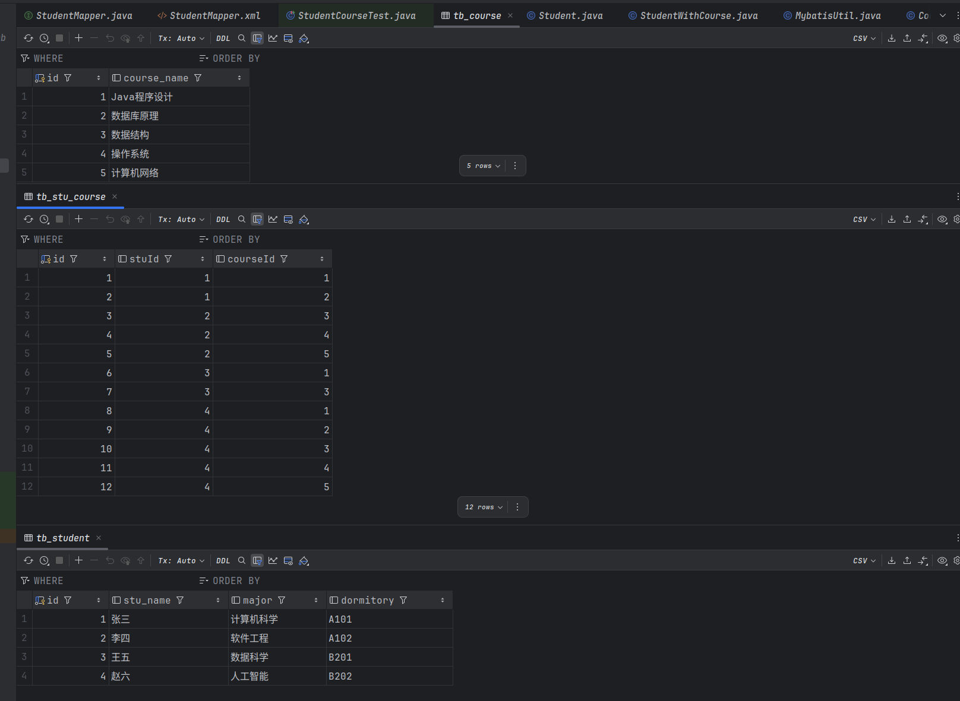
执行测试类的方法，查看id为1的学生的所有信息（包括所选课程）
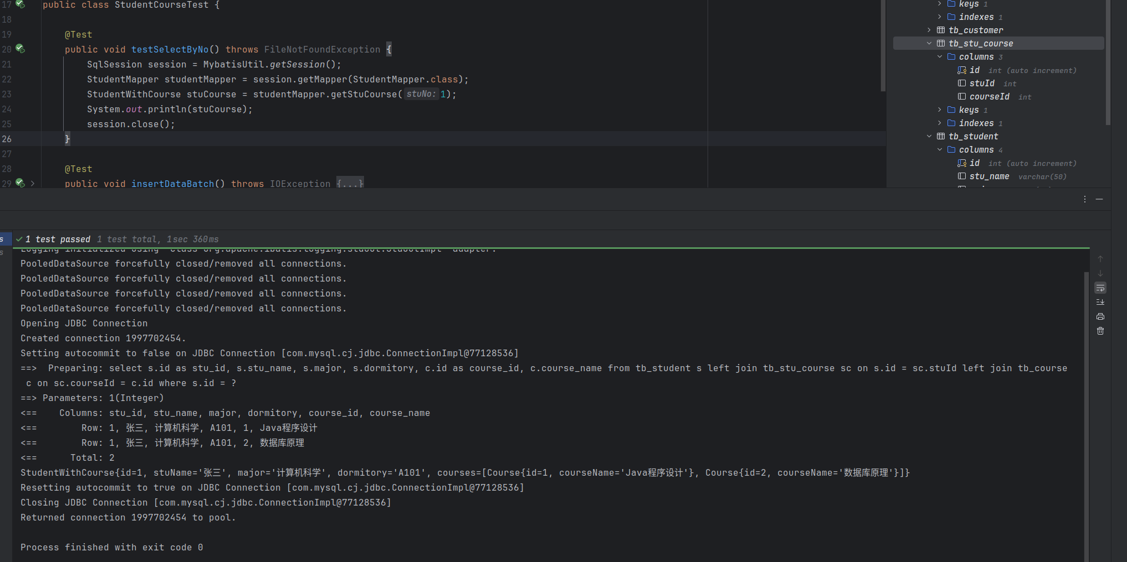
控制台观察到结果，查询成功。
- 结果分析与实验体会
通过这次实验，我理解了如何使用mybatis进行一对多的查询，并返回一个集合。

